Date of submission: 31st January 2025
Batch: C1 Roll No.: 16010122323
Student Name: Vedansh Savla
Experiment No: 2
Staff In-charge : Shivani D

TITLE: Application of RSA Algorithm for various security services like confidentiality, authentication, signature, non-repudiation and integrity
AIM: To implement Application using RSA Algorithm.
OUTCOME: Student will be able to
CO1: Explain various security goals, threats, vulnerabilities and controls
CO2: Apply various cryptographic algorithms for software security

______________________________________________________________________
Theory about SSL:

SSL/TLS is a cryptographic protocol designed to provide secure communication over a computer network, most commonly the internet. It ensures confidentiality, integrity, and authentication between two communicating applications (e.g., a web browser and a server). SSL is the predecessor to TLS, but the term "SSL" is often used interchangeably with TLS.

Block Diagram of Encryption, Decryption, Digital Signature and Digital Certificate for the implementation steps:

Implementation Details with outputs:
1. Generating RSA private /public key pair

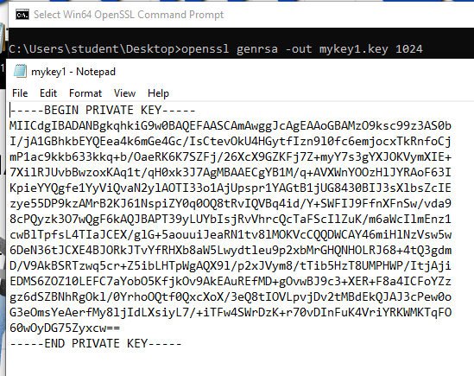

2. Public Key Encryption
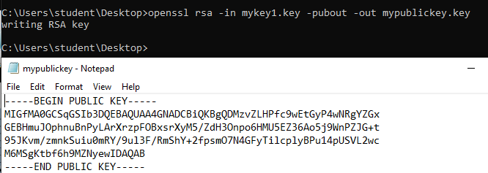

3. Public Key Encryption
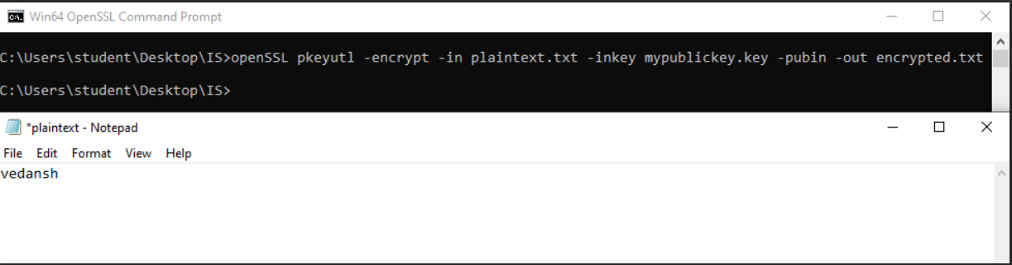

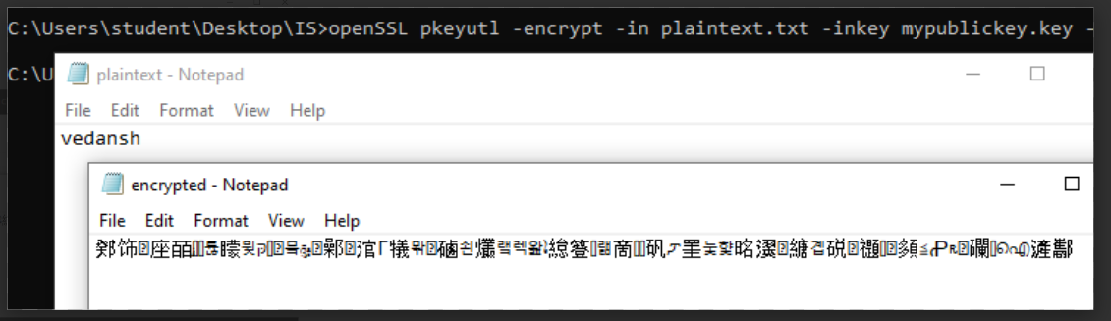

4. hash function

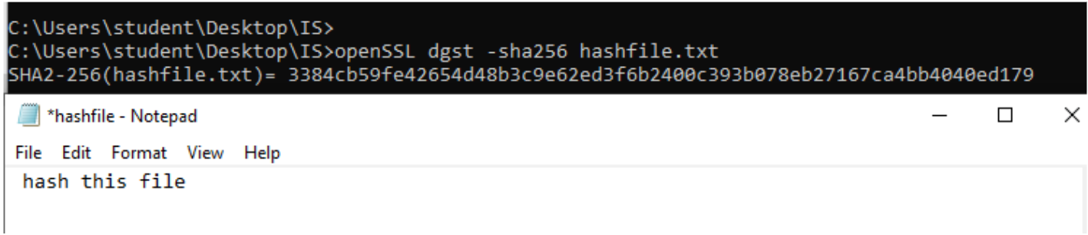

5. Certificate Creation
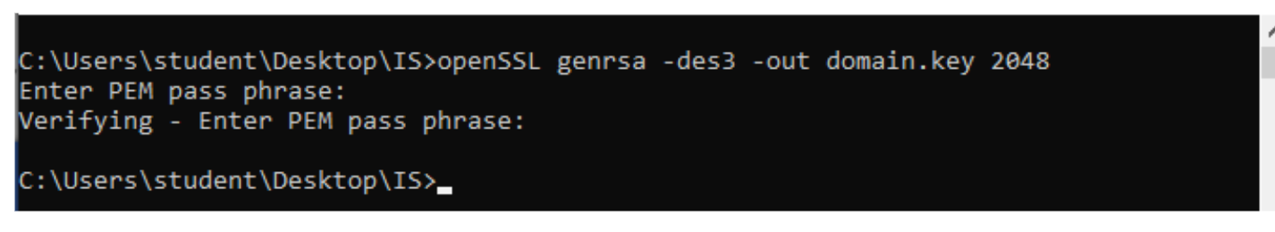
6. Certificate Creation using key
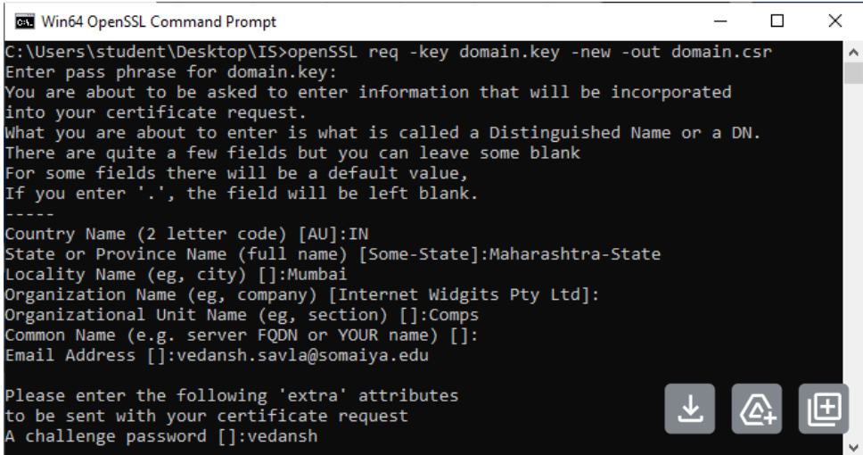
7. Create a self signed certificate

8. View the certificate
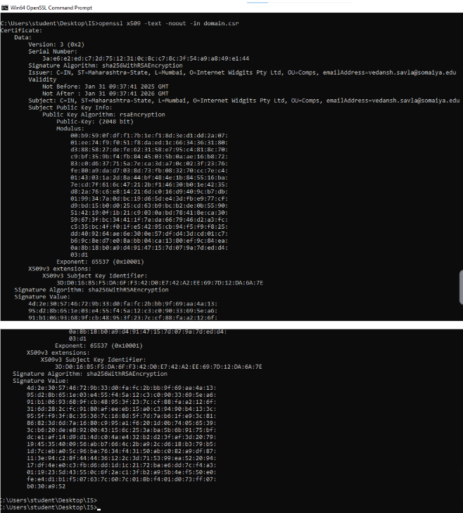

9. Digital signature
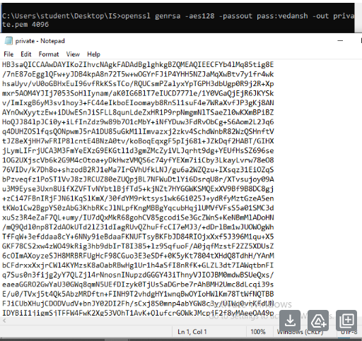

10. Digital signature
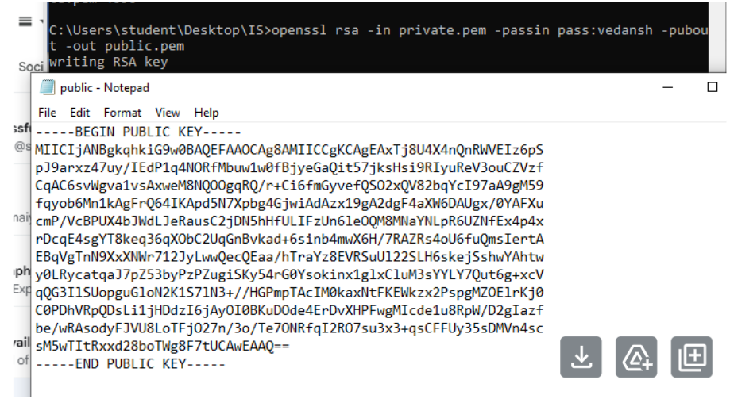
11. Create a text file
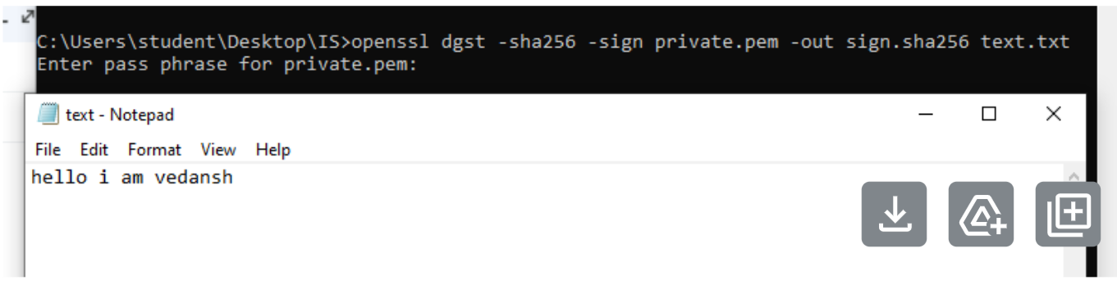

12. Generate the signature of a file

13. Verify the signature
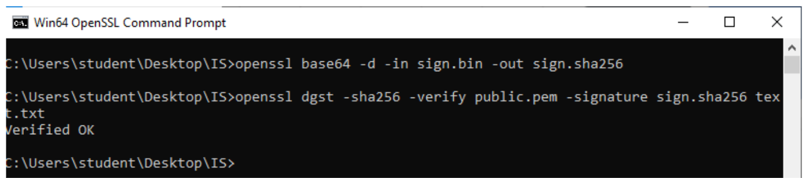

RSA Implementation details:
import math
import random

def is_prime(n):
if n < 2:
return False
for i in range(2, int(math.sqrt(n)) + 1):
if n % i == 0:
return False
return True

def generate_prime_number():
while True:
num = random.randint(100, 1000)
if is_prime(num):
return num

# Generate two distinct primes
p = generate_prime_number()
q = generate_prime_number()
while p == q:
q = generate_prime_number()

print(f"First prime (p): {p}")
print(f"Second prime (q): {q}")

n = p * q
print(f"\nModulus (n = p * q): {n}")

phi = (p - 1) * (q - 1)
print(f"\nEuler's totient φ(n): {phi}")

def gcd(a, b):
while b:
a, b = b, a % b
return a

def choose_e(phi):
e = 65537
if e >= phi:
for i in range(3, phi, 2):
if gcd(i, phi) == 1:
return i
return e

e = choose_e(phi)
print(f"\nPublic exponent (e): {e}")

def mod_inverse(a, m):
old_r, r = a, m
old_s, s = 1, 0
old_t, t = 0, 1

while r != 0:
quotient = old_r // r
old_r, r = r, old_r - quotient * r
old_s, s = s, old_s - quotient * s
old_t, t = t, old_t - quotient * t

if old_r != 1:
return None # Inverse doesn't exist
return old_s % m

d = mod_inverse(e, phi)
print(f"Private exponent (d): {d}")

def encrypt(message_str, e, n):
# Convert message to bytes
bytes_message = message_str.encode('utf-8')
m = int.from_bytes(bytes_message, byteorder='big')
if m >= n:
raise ValueError("Message is too long to encrypt with the current modulus.")
c = pow(m, e, n)
return c

def decrypt(c, d, n):
m = pow(c, d, n)
# Convert integer back to bytes
byte_length = (m.bit_length() + 7) // 8
bytes_message = m.to_bytes(byte_length, byteorder='big')
return bytes_message.decode('utf-8')

# Example usage
try:
message = input("\nEnter a message to encrypt: ")
ciphertext = encrypt(message, e, n)
print(f"\nEncrypted ciphertext (c = m^e mod n): {ciphertext}")

decrypted_message = decrypt(ciphertext, d, n)
print(f"Decrypted message: {decrypted_message}")
except ValueError as e:
print(f"Error: {e}")

Output:
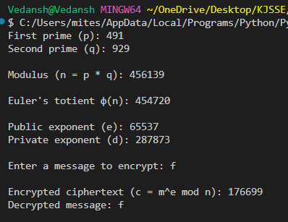

Post Lab Questions:

1. Explain and implement RSA Algorithm.
2. List the algorithms used in this experiment for OpenSSL application.

Conclusion:

